PowerPoint Presentation

Steven Anderson

Slide 1



Slide 2



The system is going to have a list of functional requirements. These will include anything that the system needs to do. Its best to describe this as focusing on what things the system requires to operate. The fact that the system needs some form of security software and consistent design are things it needs to function. Best to cover things like the security, access methods, and user interface. Also describing the features that the project will have is good for the functional description.

When reviewing the non-functional requirements it is best described as not what but how the system will do things. Describe what the user will be wanting the system to do. What the courses and practice tests will include. Go over what the system performance will be. Like how responsive the system should be and what platforms we can make the system work with. We also need to describe the process for user scheduling drivers.

Slide 3



With this slide it is best to detail what this chart describes. Tell them what actors are and what the user cases mean. Start with the user experience and describe how the user does what they do with the program. Break down what interactions the user’s actions have with the other actors. Like the server storages connected to the different parts of the program.

Then take the time to explain the admin control features. This will be what the client can do with their software. Describe what systems they will be connecting with when they use one of the use case options. This can be used to answer questions on what the admins should expect when it comes to control of the system.

Slide 4

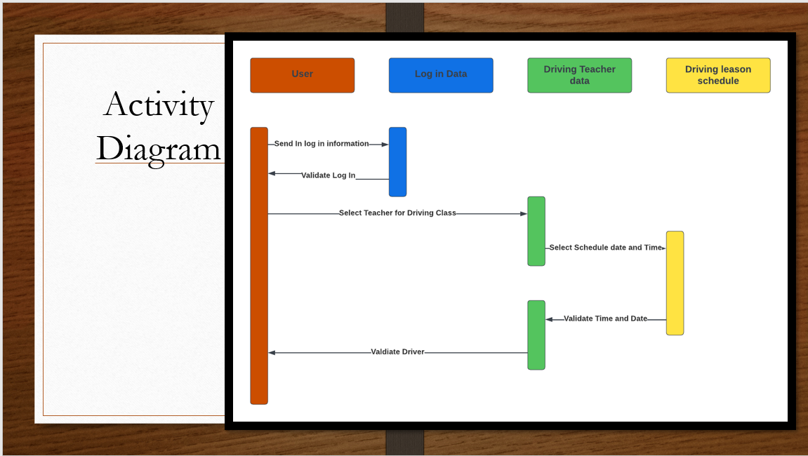

System limitation are as much constraints on the project as they are possibilities. We need to address the limits of the software that we can’t make changes to without completely rehauling the system. This is so we don’t put unachievable expectations on the system when we move forward.

When looking to the future of the system we can look at the limitations to tell us when can still be done. This is so we can know how to adapt the software to future needs instead of abandoning them since the system doesn’t do them now.

When I talk about mobile versions we need to take this as an achievable update for the system. Users may want this kind of update so they can schedule and access the systems features on the go. While we don’t have to make this something at launch I would recommend looking into this possibility for the future depending on how the system succeeds.

Slide 5

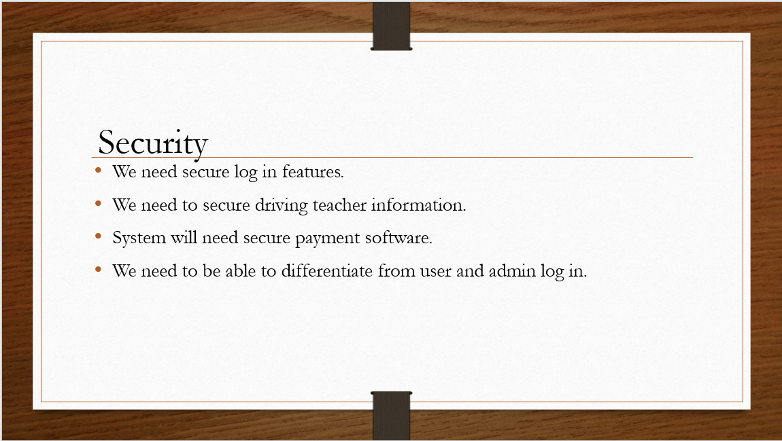

The system is going to need multiple security authentications.

We will need log in security to protect the user’s information. I would recommend looking into Microsoft's security since we might be using Azure anyways for server hosting.

We will need to secure the driver information, allow them to approve lessons and to review what appointments are coming up. We also need to make sure that no overly private information is shared about the driver teachers. We should make sure that the user can only access names and date calendars.

For payment I would recommend making the choice to use Azure or another security software early in development. This is probably the most important part of the security we will need. The system itself can’t store the payment information, the 3rd party software needs to handle the card information and handle any auto payments that we need to take.

Slide 6

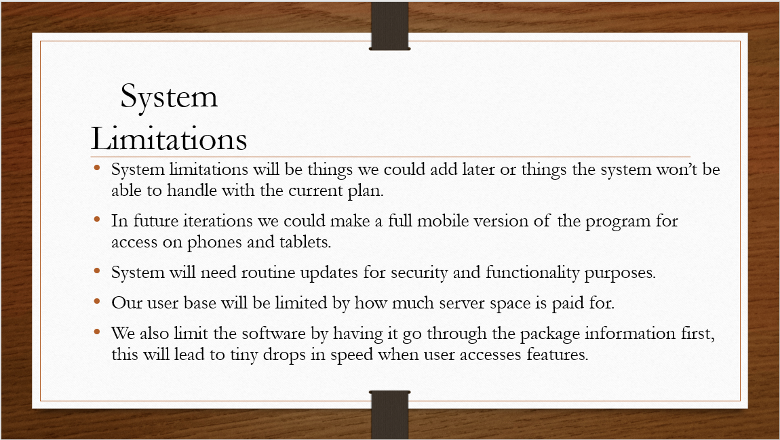

System limitation are as much constraints on the project as they are possibilities. We need to address the limits of the software that we can’t make changes to without completely rehauling the system. This is so we don’t put unachievable expectations on the system when we move forward.

When looking to the future of the system we can look at the limitations to tell us when can still be done. This is so we can know how to adapt the software to future needs instead of abandoning them since the system doesn’t do them now.

When I talk about mobile versions we need to take this as an achievable update for the system. Users may want this kind of update so they can schedule and access the systems features on the go. While we don’t have to make this something at launch I would recommend looking into this possibility for the future depending on how the system succeeds.